TASK 11 – Implementation, Testing and Validation

Aim
To implement and test the Campus Smart-Parking System using Java and validate its parking allocation, release, and fee calculation operations.

1. Implementation
The system uses the following classes and components:
- Vehicle – stores vehicle details.
- ParkingSlot – represents an individual parking slot.
- ParkingFloor – manages slots on a floor.
- ParkingFacility – allocates and releases parking slots.
- ParkingFeeCalculator – calculates parking charges.

2. Test Cases
Test Case | Input / Condition | Expected Output
TC01 | Allocate a vehicle when a slot is free | Slot allocated successfully
TC02 | Allocate vehicles until all slots are occupied | All available slots allocated
TC03 | Allocate a vehicle when parking is full | null or parking-full message
TC04 | Release an occupied slot | true
TC05 | Release an already-free slot | false
TC06 | Release an invalid floor | false
TC07 | Release an invalid slot number | false
TC08 | Calculate fee for 2 hours at ₹50 per hour | ₹100
TC09 | Calculate fee for zero minutes | ₹0
TC10 | Allocate a vehicle after releasing a slot | Released slot can be reused

3. Sample Java Testing Code
public class ParkingTest {
public static void main(String[] args) {
ParkingFacility p = new ParkingFacility(new int[]{2, 1});
System.out.println(p.allocate("TN01AB1111") != null);
System.out.println(p.allocate("TN02CD2222") != null);
System.out.println(p.allocate("TN03EF3333") != null);
System.out.println(p.allocate("TN04GH4444") == null);
System.out.println(p.release(0, 1));
System.out.println(p.release(0, 1));
System.out.println(p.allocate("TN04GH4444") != null);
}
}
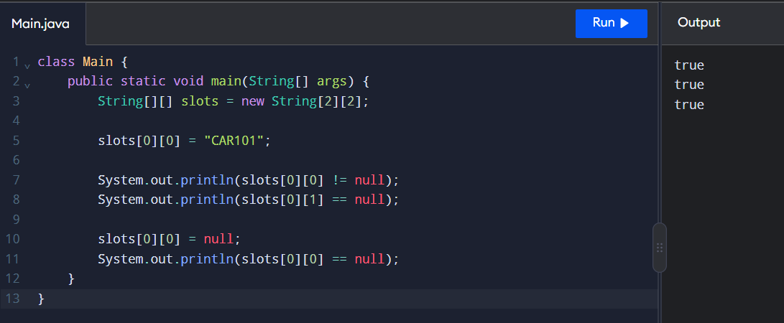
Expected Output
true
true
true
true
true
false
true

4. Daily Parking Fee Collection
The system can calculate daily revenue by adding the parking fees collected from all vehicles.
double totalCollection = 0;
double fee1 = 100;
double fee2 = 150;
double fee3 = 50;
totalCollection = fee1 + fee2 + fee3;
System.out.println("Daily Collection: Rs. " + totalCollection);
Output
Daily Collection: Rs. 300.0

5. Array vs ArrayList vs HashMap
Feature | Array | ArrayList | HashMap
Storage | Fixed size | Dynamic size | Key-value pairs
Access | Using index | Using index | Using key
Size | Cannot grow automatically | Can grow or shrink | Can grow or shrink
Best use | Fixed parking slots | Dynamic vehicle list | Vehicle number lookup
Example | String[] slots | ArrayList<String> | HashMap<String, Vehicle>

Result
The Campus Smart-Parking System was implemented and tested using Java. The test cases validated slot allocation, full-parking handling, slot release, invalid inputs, and reuse of released slots. Daily parking revenue was calculated, and arrays, ArrayList, and HashMap were compared for suitable data storage.

